Domain:

* It defines a value range.
* Describes technical attributes of a field like data type, length and value range for a table field
* It is assigned to data element.
* Can assign to any number of data elements.
* All table fields or structure components that use this data element then have the value range defined by the domain.

SE11 T-code

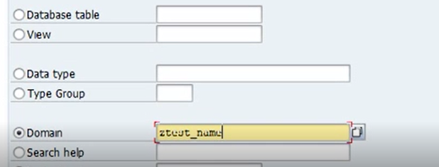

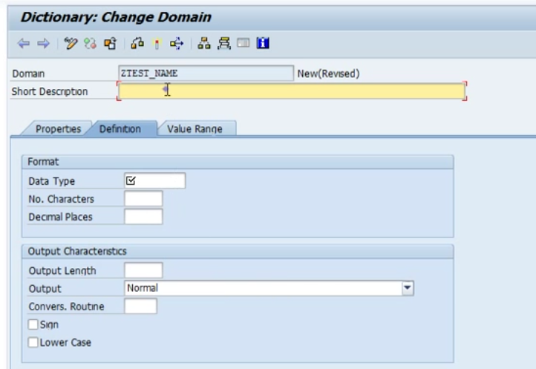

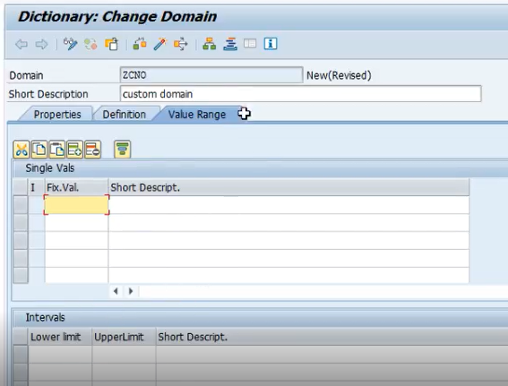

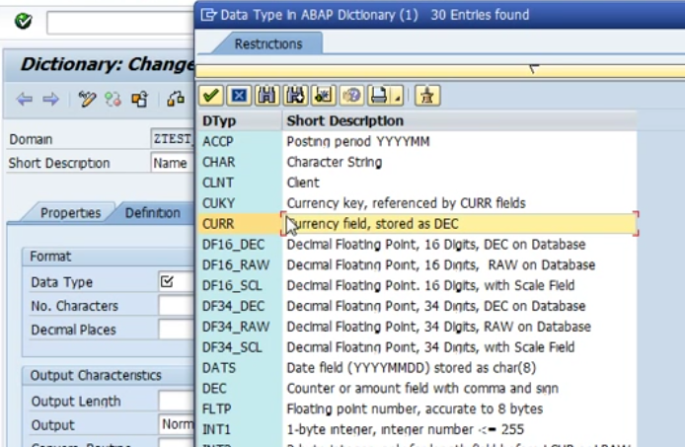

Save and activate.

Data Elements:

* Provides field labels and documentation for the table field.

